**SAMUDRALA NIKITHA**

**192011225**

**OBJECT ORIENTED ANALYSIS AND DESIGN-CSA1140**

**PACKAGE DIAGRAM**:

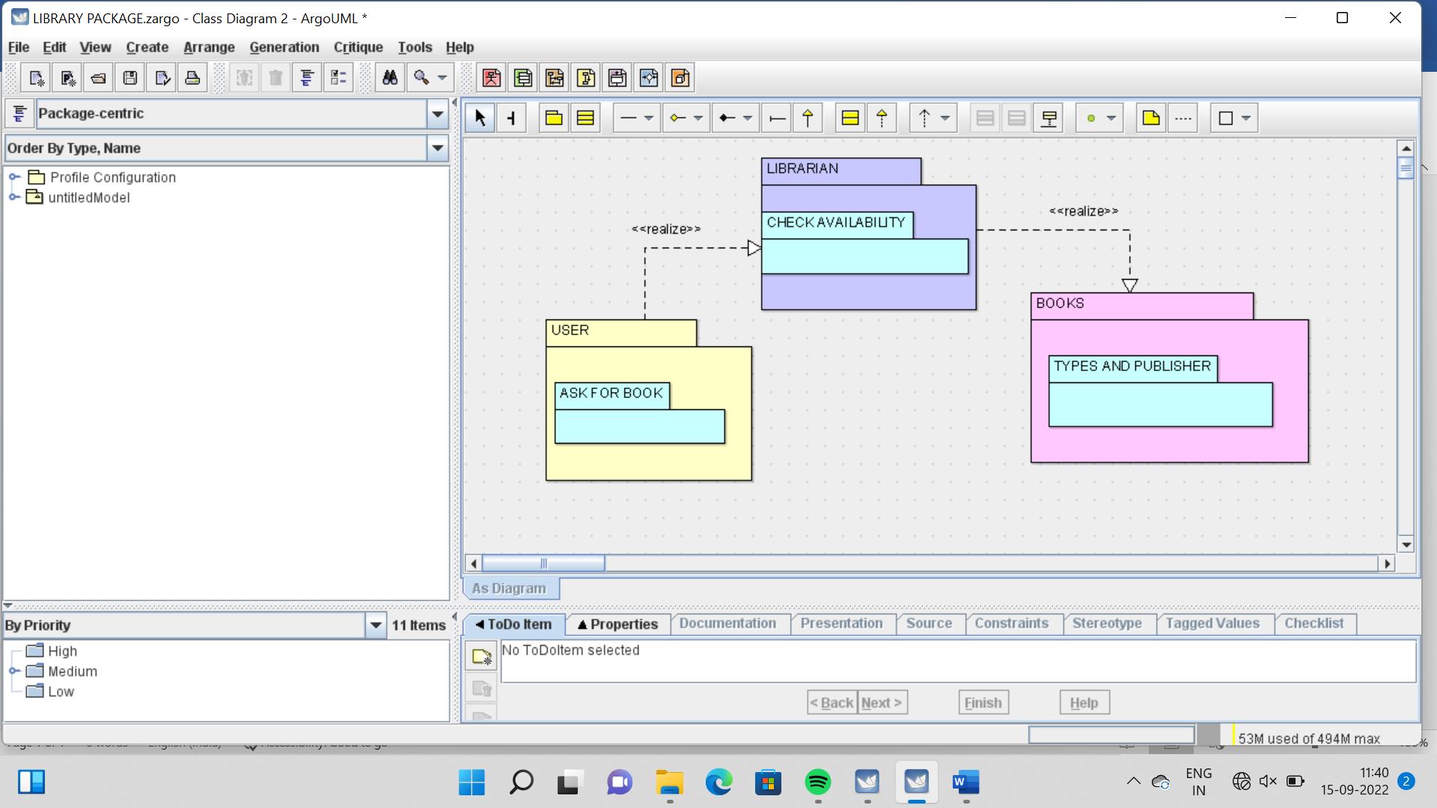

**ACTIVITY DIAGRAM**

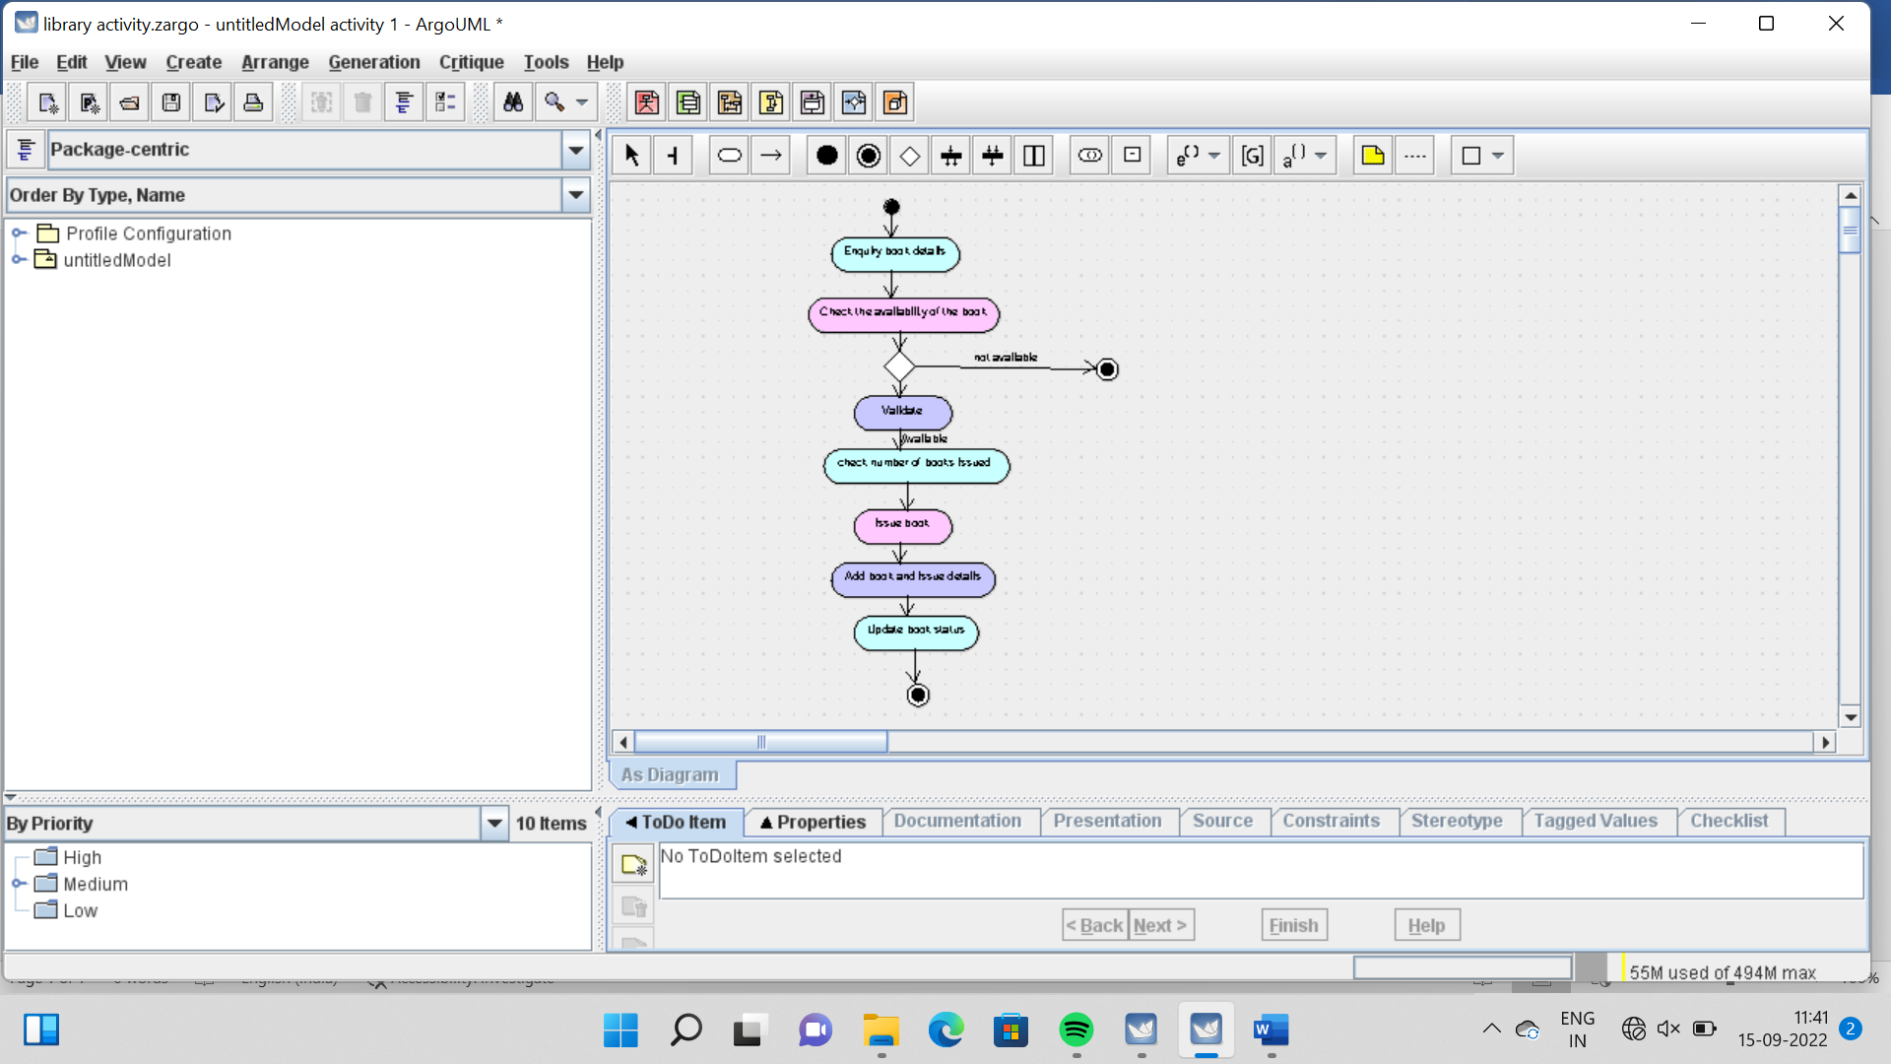

CLASS DIAGRAM

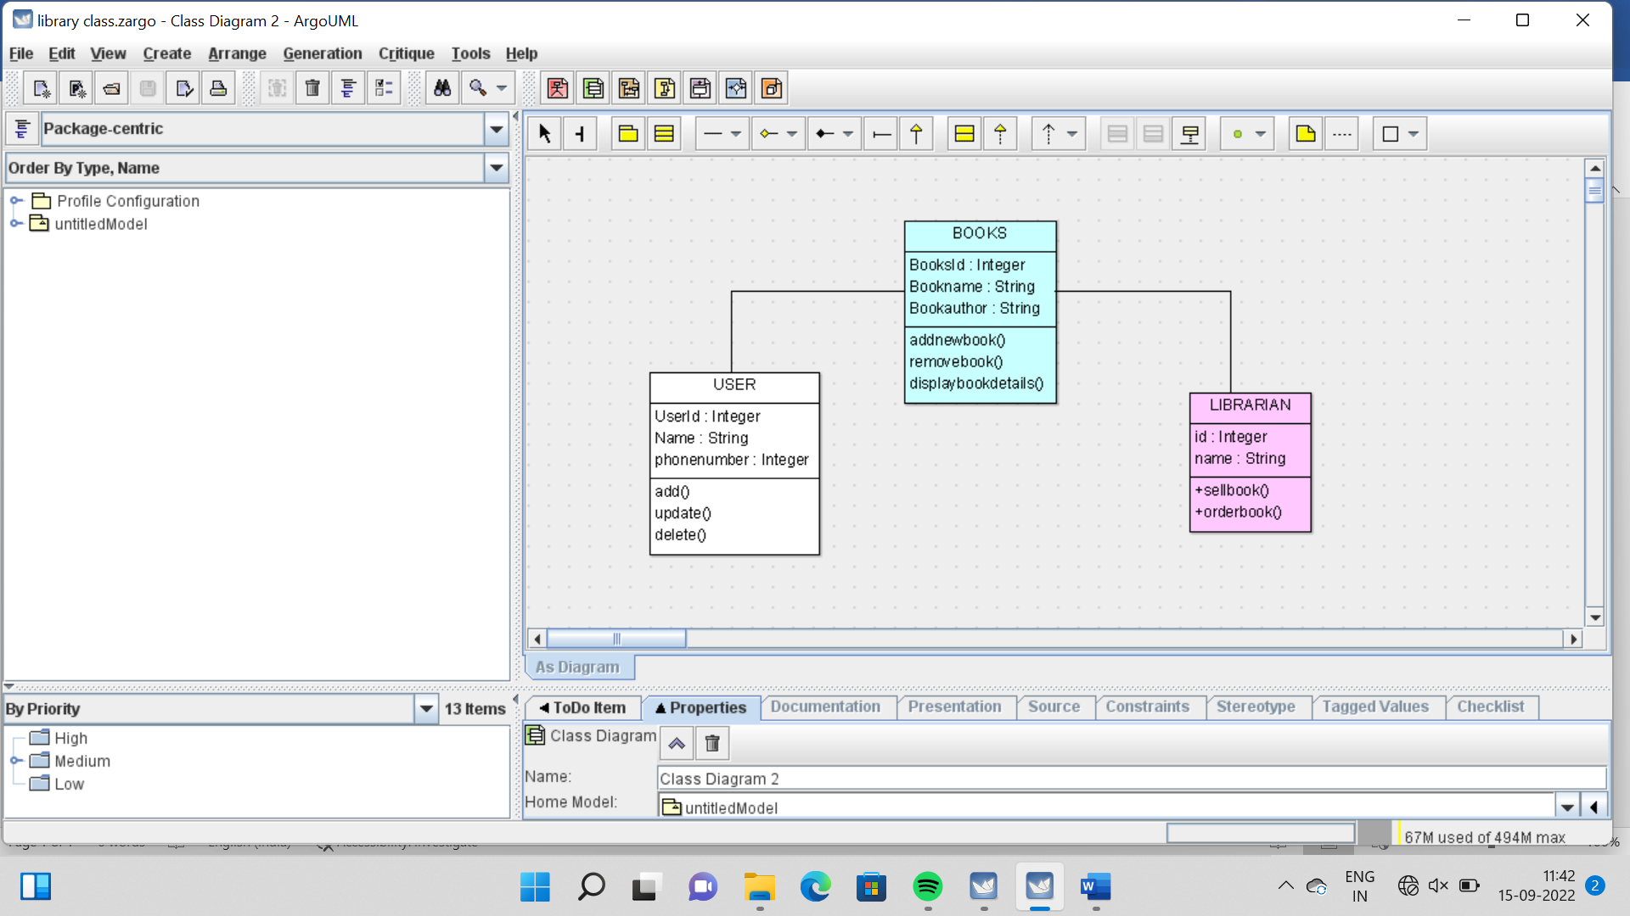

**SKELETON DIAGRAM**:

**USER**

import java.util.Vector;

public class USER {

public Integer UserId;

public String Name;

public Integer phonenumber;

public Vector myBOOKS;

public void add() {

}

public void update() {

}

public void delete() {

}

}

**BOOKS**

import java.util.Vector;

public class BOOKS {

public Integer BooksId;

public String Bookname;

public String Bookauthor;

public Vector myUSER;

public Vector myLIBRARIAN;

public void addnewbook() {

}

public void removebook() {

}

public void displaybookdetails() {

}

}

**LIBRARIAN**

import java.util.Vector;

public class LIBRARIAN {

public Integer id;

public String name;

public Vector myBOOKS;

public void +sellbook() {

}

public void +orderbook() {

}

}

COLLABORATION DIAGRAM

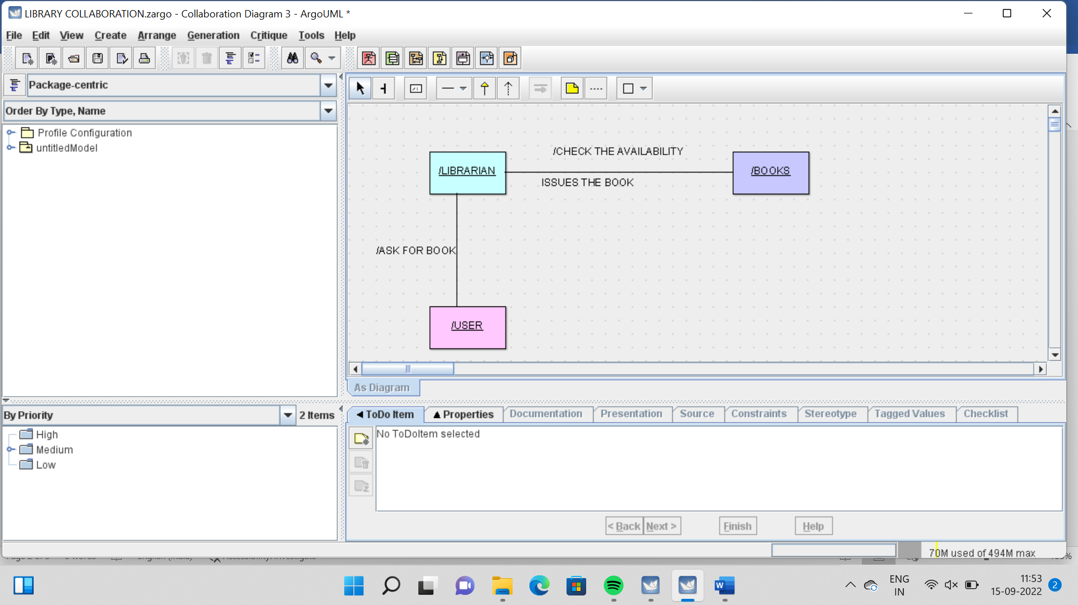

DEPLOYMENT DIAGRAM

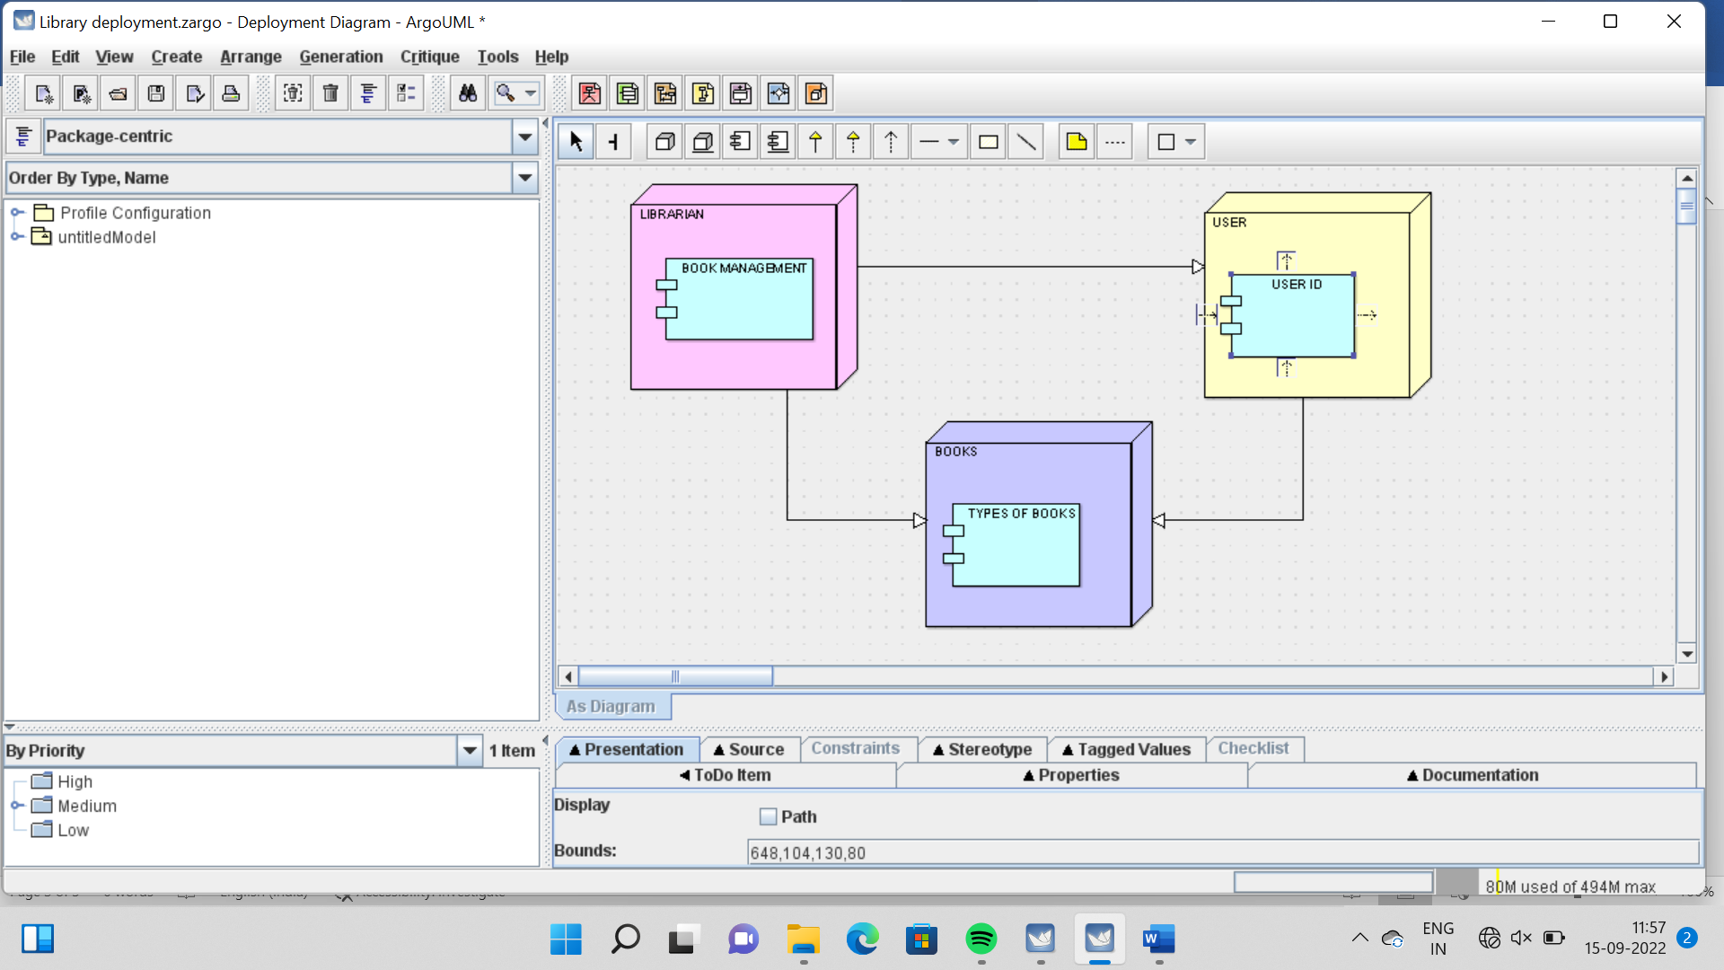

USE CASE DIAGRAM

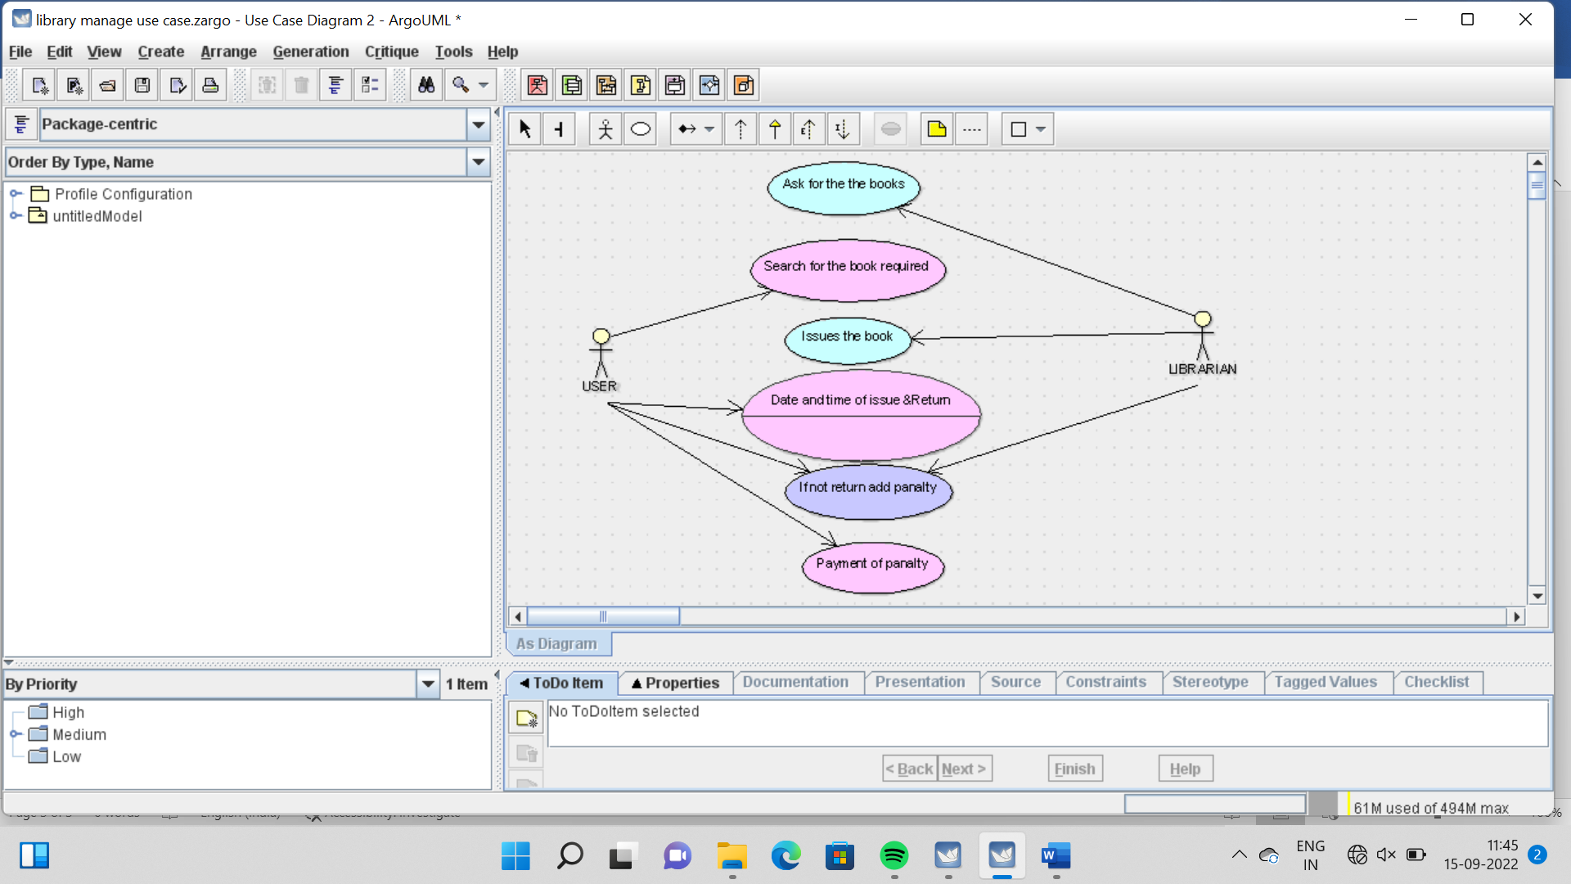

SEQUENCE DIAGRAM

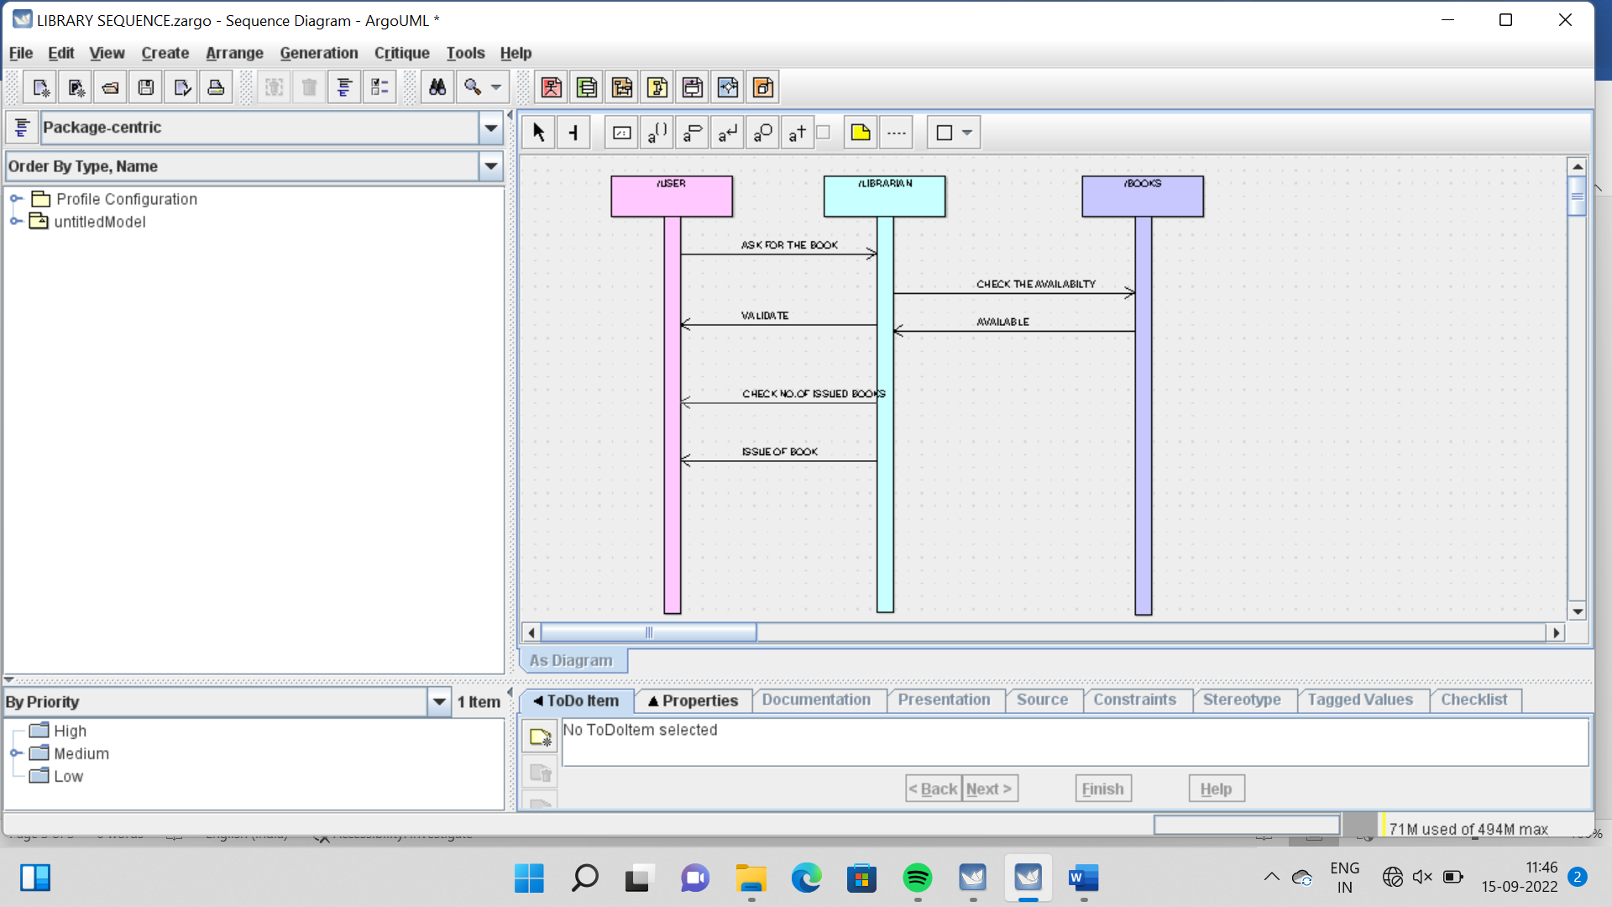

STATE CHART DIAGRAM

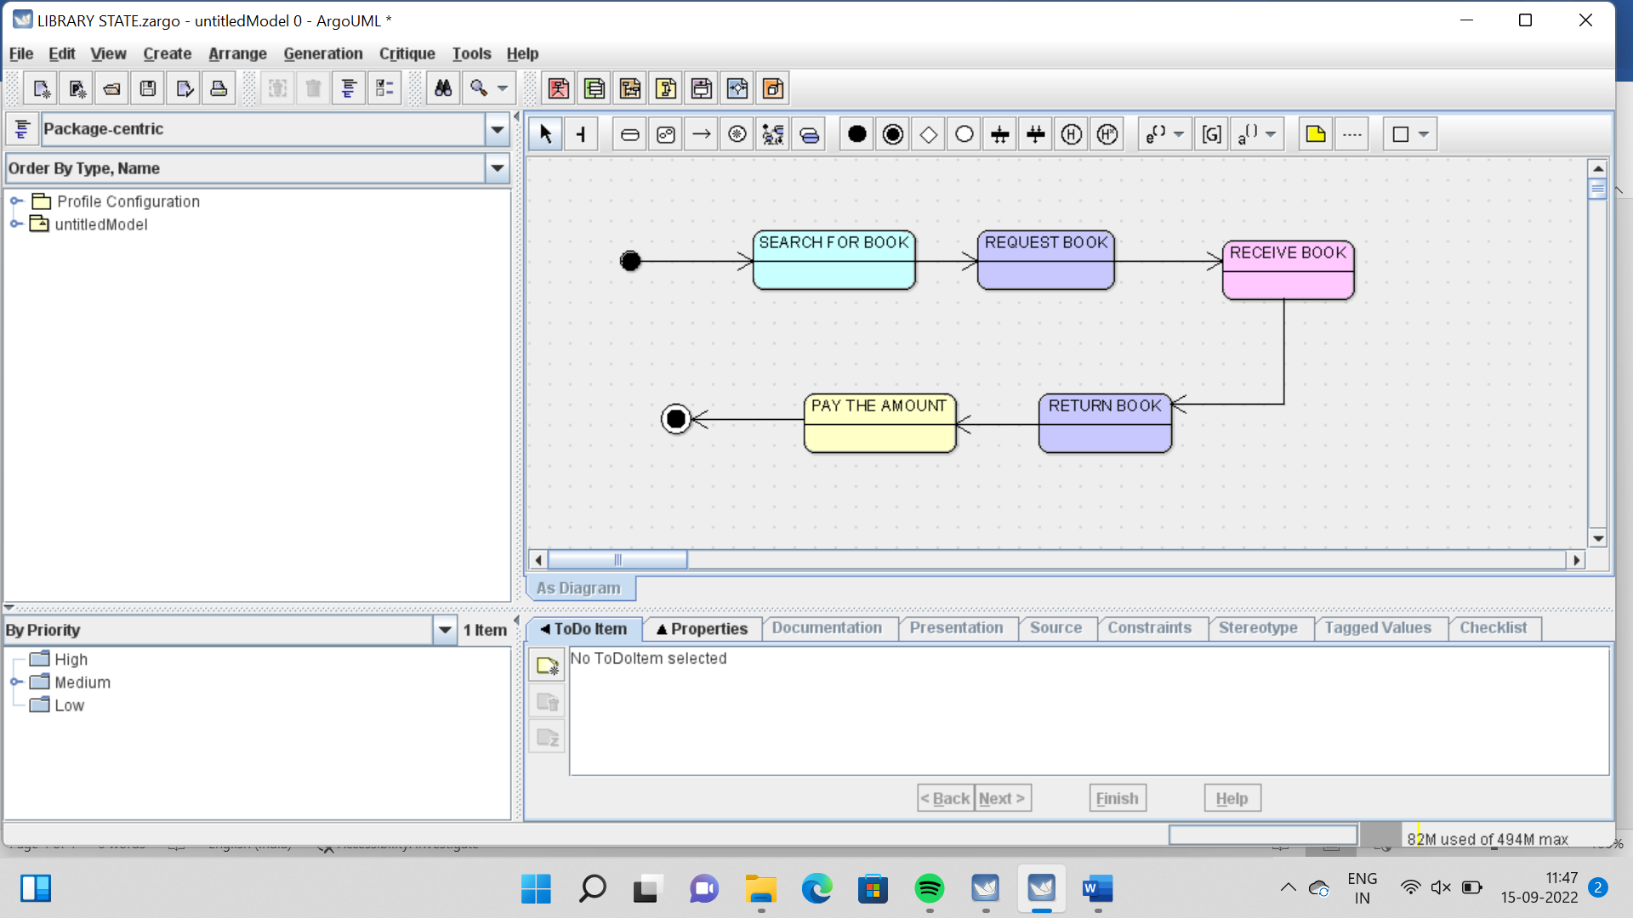

COMPONENT DIAGRAM

